13 – Stones – Jack Flash
Original key: B Us: same
KORG:8VES YAM: WURLI, Organ0
Comp pattern next page--->
Intro:
bar counts gtr2, bass2, drums2, "three measures"
[Verse 1]
riff 2x, then voice over riff 4x
Chorus: 7 bars + "three measures"
[Verse 2] exact repeat + Chorus
Middle mumble: 8 bars + "three measures"
Verse 3 has voice over riff 8x
Same chorus
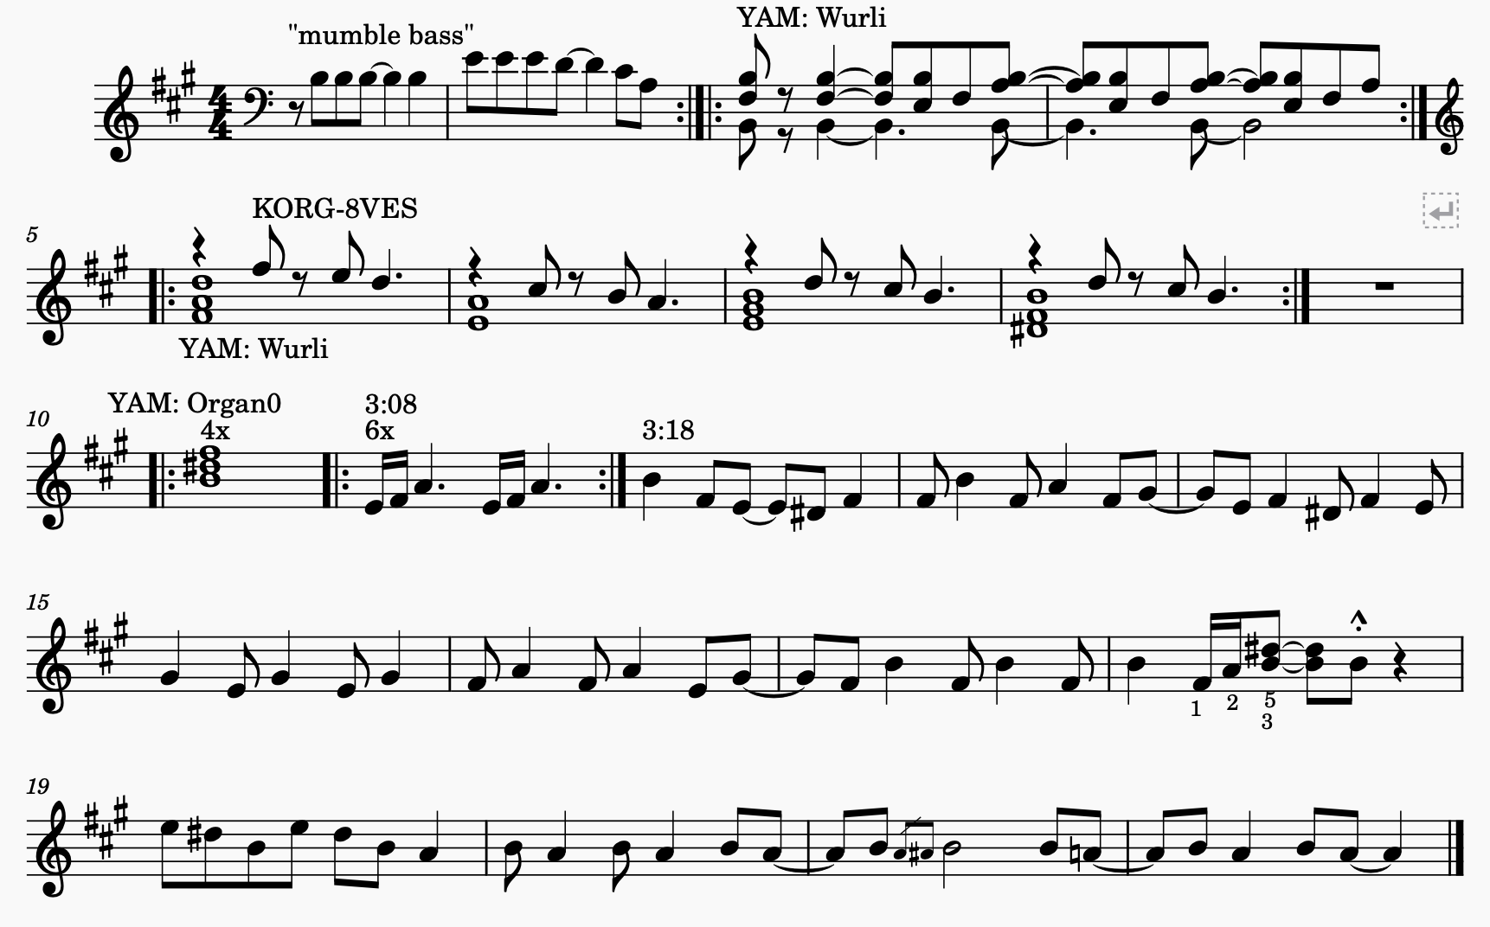
Then mumble until end

